|  |  |  |
| --- | --- | --- |
| **Experimental Design Diagram: Part 1** | | |
| **IV: Type of food** | | **DV:** The glucose concentration in the food before and after adding invertase  **Unit: % concentration** |
| **Levels of IV:** | **Coconut Water** | **How many repeated trials?**  **3**  **_________** |
| **Rice milk** |
| **Almond Breeze** |
| **Whole milk** |
| **Soy milk** |
| **POM** |
| **Naked** |
| **Gatorade** |
| **Fanta** |
| **Apple Juice** |
| **Orange Juice** |
| **Blueprint Juice** |
| **Peanut Butter** |
| **Nutella** |
| **Constants:**   * Amount of time the invertase sits in the food before measuring * Amount of invertase * Temperature of the food * Temperature of the invertase * Amount of food | | |

|  |  |  |
| --- | --- | --- |
| **Experimental Design Diagram: Part 2** | | |
| **IV: pH of the food**  **Unit:** | | **DV: percent of glucose concentration**  **Unit: % concentration** |
| **Levels of IV:** | **Control:**  No control | **How Many Repeated Trials?**  **_____3____** |
| **Acidic POM** |
| **Normal POM** |
| **Basic POM** |
| **Acidic Naked** |
| **Normal Naked** |
| **Basic Naked** |
| **Acidic Fanta** |
| **Normal Fanta** |
| **Basic Fanta** |
| **Constants:**   * Amount of time the invertase sits in the food before measuring * Amount of invertase * Temperature of the food * Temperature of the invertase * Amount of food | | |

|  |  |  |  |  |  |  |  |  |  |  |  |  |
| --- | --- | --- | --- | --- | --- | --- | --- | --- | --- | --- | --- | --- |
|  | | The Effect of pH on the Reaction | | | | | | | | | | |
| pH of food | | Glucose Concentration (%) | | | | | | | | | | |
|  | Before Adding Invertase | | | 15 minutes After Adding Invertase | | | Before Adding Invertase | | 15 minutes After Adding Invertase | |
| pH | Trial 1 | Trial 2 | Trial 3 | Trial 1 | Trial 2 | Trial 3 | Range | Average | Range | Average |
| Naked | Acidic | 2 | 0 | 0 | 0 | 0 | 0 | 0 | 0 | 0 | 0 | 0 |
| Normal | 4 | 1.5 | 1.5 | 1.5 | 3.5 | 3 | 3 | 0 | 1.5 | 0.5 | 3.1667 |
| Basic | 9 | 1 | 1 | 1 | 1 | 1 | 1 | 0 | 1 | 0 | 1 |
| Fanta | Acidic | 2 | 1 | 1 | 1 | 1 | 1 | 1 | 0 | 1 | 0 | 1 |
| Normal | 2.5 | 2 | 2 | 2 | 2 | 2 | 2 | 0 | 2 | 0 | 2 |
| Basic | 8 | 2.5 | 2.5 | 2.5 | 3 | 3 | 3 | 0 | 2.5 | 0 | 3 |
| POM | Acidic | 2 | 1 | 1 | 1 | 1 | 1 | 1 | 0 | 1 | 0 | 1 |
| Normal | 4 | 5 | 5 | 5 | 5.5 | 5.5 | 5.5 | 0 | 5 | 0 | 5.5 |
| Basic | 8 | 2.5 | 2.5 | 2.5 | 2.5 | 2.5 | 2.5 | 0 | 2.5 | 0 | 2.5 |

|  |  |  |
| --- | --- | --- |
| **Experimental Design Diagram** | | |
| **IV: pH of the food**  **Unit:** | | **DV: Amount of glucose**  **Unit: g** |
| **Levels of IV:** | **Control:**  No control | **How Many Repeated Trials?**  **_____3____** |
| **Acidic POM** |
| **Normal POM** |
| **Basic POM** |
| **Acidic Naked** |
| **Normal Naked** |
| **Basic Naked** |
| **Acidic Fanta** |
| **Normal Fanta** |
| **Basic Fanta** |
| **Constants:**   * Amount of time the invertase sits in the food before measuring * Amount of invertase * Temperature of the food * Temperature of the invertase * Amount of food | | |
| **Hypothesis:**  If the pH of a food is changed from it’s normal setting and tested for converting sucrose to glucose, then it will have a slower rate of conversion because the enzyme changes shape so that it does not fit with the substrate(in this case, the food it is trying to break down) and the reaction does not work properly | | |

|  |  |  |  |  |  |  |  |  |  |  |
| --- | --- | --- | --- | --- | --- | --- | --- | --- | --- | --- |
|  | The Glucose Concentration of Types of Foods | | | | | | | | | |
|  | Percent of Glucose Concentration(%) | | | | | | | | | |
|  | Before Invertase | | | 15 minutes After Invertase | | | Before Invertase | | 15 minutes After Invertase | |
| Type of Food | Trial 1 | Trial 2 | Trial 3 | Trial 1 | Trial 2 | Trial 3 | Mean | Range | Mean | Range |
| Coconut water | 0.3 | 0.3 | 0.3 | 0.45 | 0.5 | 0.5 | 0.3 | 0 | 0.483 | 0.05 |
| Rice milk | 0.3 | 0.3 | 0.3 | 0.4 | 0.4 | 0.4 | 0.3 | 0 | 0.4 | 0 |
| Almond Breeze | 0 | 0 | 0 | 0.2 | 0.25 | 0.2 | 0 | 0 | 0.216 | 0.05 |
| Whole milk | 0 | 0 | 0 | 0 | 0 | 0 | 0 | 0 | 0 | 0 |
| Soy milk | 0 | 0 | 0 | 0.1 | 0 | 0.1 | 0 | 0 | 0.066 | 0.1 |
| POM | 5 | 5 | 5 | 5.5 | 5.5 | 5.5 | 5 | 0 | 5.5 | 0 |
| Naked | 1.5 | 1.5 | 1.5 | 3.5 | 3 | 3 | 1.5 | 0 | 3.166 | 0.5 |
| Gatorade | 1.3 | 1.3 | 1.3 | 2 | 2 | 2 | 1.3 | 0 | 2 | 0 |
| Fanta | 4 | 4 | 4 | 5 | 5 | 4 | 4 | 0 | 4.666 | 1 |
| Apple Juice | 2.5 | 2.5 | 2.5 | 3 | 3 | 3 | 2.5 | 0 | 3 | 0 |
| Orange Juice | 2.5 | 2.5 | 2.5 | 3 | 4 | 3 | 2.5 | 0 | 3.333 | 1 |
| Blueprint | 2.5 | 2.5 | 2.5 | 3 | 4 | 3 | 2.5 | 0 | 3.333 | 1 |
| Peanut butter | 0 | 0 | 0 | 1 | 1 | 1 | 0 | 0 | 1 | 0 |
| Nutella | 0 | 0 | 0 | 4 | 3 | 3 | 0 | 0 | 3.333 | 1 |

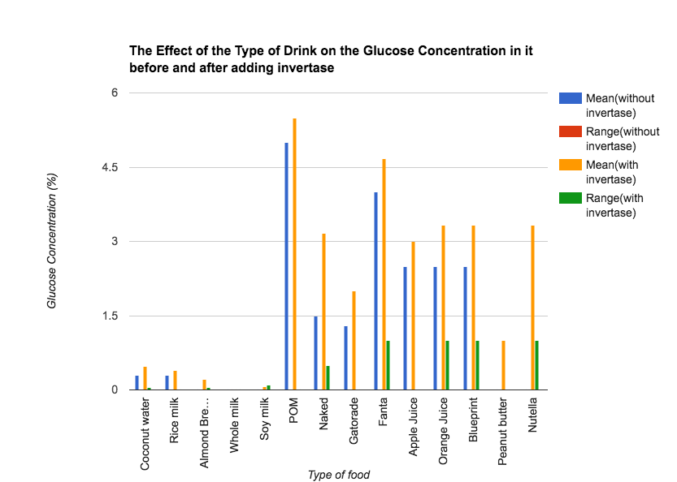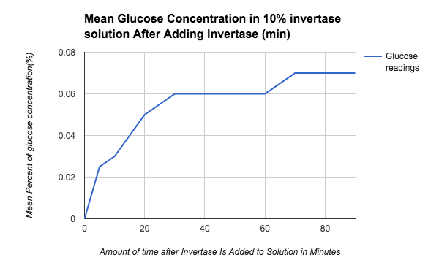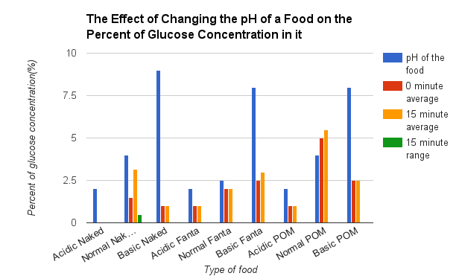

The experiment’s IV was the different types of drinks. The levels were Coconut water, Almond Breeze, Whole milk, POM, Naked, Soy Milk, Fanta, Apple Juice, Orange Juice, Blueprint, Smart balance, Peanut butter, Nutella, Gatorade, Syrup, and Rice milk. The DV of the experiment was measured in grams of glucose. Three of the types of milk tested had relatively little amounts of glucose in them, while the other type of milk, rice milk, had 4 grams of glucose, a relatively high amount. Other high glucose drinks included POM, Fanta, and Naked. Gatorade came out on the middle of the spectrum, along with orange juice. Most of the drinks tested had 3 grams of glucose. POM had the highest amount of glucose, with Fanta in second place. Whole milk, almond milk, and soy milk had the lowest amount of glucose. None of the drinks had data with a large range. The range for coconut water and almond breeze was 0.05. The range for Rice milk, Whole milk, Gatorade, POM, Apple juice, and Peanut butter was 0. Soy milk had a range of 0.1. Naked had a range of 0.5. Fanta, Orange juice, Blueprint, and Nutella had a range of one. The fact that the ranges were so low shows precise data. The data is reliable, because the variation for the different types of drinks was small.

The IV was the pH of the different foods. The levels were POM with pH’s of 2, 4, and 8, Fanta with pH’s of 2, 2.5, and 8, and Naked with pH’s of 2, 4, and 9. For POM, the natural pH was 4, for Fanta, the natural pH was 2.5, and for Naked, the natural pH was 4. The DV of the experiment was measured in grams of glucose produced. When tested, all of the drinks with the highest amounts of glucose were at their natural pH level, and the drinks with the lowest amounts of glucose were the most acidic drinks. The ranges for all of them were zero, except Naked with a pH of four, which had a range of 0.5. This shows precise data. The data is reliable, because the variation for the different types of drink was little.

The purpose of this experiment was to figure out how to avoid foods with high glucose concentrations. This is important because one of the most widespread diseases, diabetes, is the result of your body being unable to manage large amounts of glucose. The hypothesis was that if more heavily processed foods are tested for converting sucrose to glucose, then they will have a faster rate of conversion because the removal of fiber makes it easier to absorb water into the food and there are less steps to break down the sugar. It was difficult to prove or disprove the hypothesis, but some drinks such as Fanta and POM are obviously more processed than others, and they had high amounts of glucose. Drinks like whole milk don’t seem to be processed very much, and whole milk had a very low amount of glucose. The data showed that rice milk had an unusually high amount of glucose compared to the other types of milk, which had an average near zero. When looking at the glucose, the results on the test strip may have been slightly misjudged, and on the glucose test strips, and the invertase might not have been poured in at the same exact time because the invertase came in a bottle in which individual drops had to be squeezed out, taking more time than if it were to be dumped out at once. The experiment could also have functioned better if the invertase had been measured out in cups. The experiment could go further if it looked at the food products that advertised lower fat content and see whether the amounts of sugar went up.

The purpose of this experiment is to discover whether changing the pH of a drink can change the speed of conversion from the sucrose inside it to glucose. The experiment is relevant to the real world because it addresses one of the leading problems: diabetes, the body’s inability to manage glucose. A method of inhibiting the conversion of sucrose to glucose could be very useful. The hypothesis was that if the pH of a food is changed from its normal setting and tested for converting sucrose to glucose, then it will have a slower rate of conversion because the enzyme changes shape so that it does not fit with the substrate(in this case, the food it is trying to break down) and the reaction does not work properly. The hypothesis was supported, because all of the drinks tested at their normal pH had a higher conversion rate than the drinks tested at an altered rate. For example, Fanta’s normal rate had an average conversion rate of 5.5, and the altered drinks had an average of 1 and 2.5. The exception was POM, where the more acidic drink had the slowest rate of conversion, and the drink that was the most basic had the fastest rate of conversion. One of the major findings was that if the pH is at its natural setting, than in has the highest rate of conversion. Another finding was that if the drink is more basic, then it should have the second highest amount of sugar. The experiment was not tested with the same measures of acidity and basicity for each type of drink, so you can’t compare it to other drinks. Another problem that might have occurred is that only three types of drinks were tested, so the experiment might not have enough data. The experiment could test a few more types of drinks for more data points. Extensions could include creating different sucrose solutions and including more changes in pH.

Diabetes and obesity are reaching epidemic levels. Sugar is a big contributor to these serious diseases. Diabetes is a result of the body’s inability to process sugar, specifically glucose. The body converts sucrose (table sugar) into glucose, using the enzyme sucrase. Sucrose consists of glucose and fructose bonded together. In the small intestine, sucrose to an enzyme sucrase(invertase is substituted for sucrase). The binding places stress on the glucose-fructose bond and water breaks the bond. Glucose and fructose are released. The speed of conversion is important because the faster the reaction the more stress is placed on the body to manage sugar. This experiment seeks to investigate how the characteristics of food, specifically level of processing and pH, impact the conversion of sucrose into glucose.

If the pH of a food is changed from its normal setting and tested for converting sucrose to glucose, then it will have a slower rate of conversion because the enzyme changes shape so that it does not fit with the substrate (in this case, the food it is trying to break down) and the reaction does not work properly.

If more heavily processed foods are tested for converting sucrose to glucose, then they will have a faster rate of conversion because the removal of fiber makes it easier to absorb water into the food and there are less steps to break down the sugar.

* Invertase (3 grams)
* Distilled Water (50 grams)
* Sucrose (50 grams)
* Glucose test strips (100)
* Baking soda (50 grams)
* Vinegar (50 mL)
* Nutella (50 mL)
* Syrup (50 mL)
* Coconut Water (50 mL)
* Rice Milk (50 mL)
* Whole Milk (50 mL)
* Blueprint (juice)(50 mL)
* Almond Breeze (50 mL)
* Apple juice (50 mL)
* Orange juice (50 mL)
* Soy milk (50 mL)
* Peanut Butter (50 mL)
* POM (200 mL)
* Naked (200 mL)
* Fanta (200 mL)
* Gatorade (50 mL)
* pH testing strips(100)
* Graduated cylinder
* Measuring scale

Part A: Testing the Glucose Strips.  The glucose strips are tested for accuracy using solutions with known glucose concentrations.

1. Make glucose solutions with 2%, 1%, 0.5%, 0.25%, 0.125%, 0.0625%, 0% glucose.
   1. Label six cups 2%, 1%, 0.5%, 0.25%, 0.125%, and 0.0625% and 0%
   2. Pour 200 mL of water into a cup labeled 2%
   3. Pour 100 mL of water into six other labeled cups
   4. Pour 4 grams of glucose into the cup labeled 2%
   5. Put 4 drops of food coloring into the cup labeled 2%
   6. Pour 100 mL of solution 2% into the cup labeled 1% to make a 1% solution
   7. Pour 100 mL of solution 1% into the cup labeled 0.5% to make a 0.5% solution
   8. Pour 100 mL of solution .5% into the cup labeled 0.25% to make a 0.25% solution
   9. Pour 100 mL of solution 0.25% into the cup labeled 0.125% to make a 0.125% solution
   10. Pour 100 mL of solution 0.125% into the cup labeled 0.0625% to make a 0.0625% solution
   11. Pour 100 mL of water in the cup labeled 0%
2. Dip a glucose test strip in the 2% solution.  After 30 seconds compare the color to the chart below
3. The color of the test strip determines the solution level according to the instructions on the test strip bottle.
   1. Compare the colors on the end of the strip to those on the chart above.
4. Repeat two more times for the 2% solution
5. Repeat for each solution
6. If the glucose strip accurately measures the glucose concentration, proceed with testing; otherwise, acquire new test strips

Part B: Testing the enzyme activity with a control.  On a known amount of sucrose, understand the timing of the enzyme reaction.  Determining the best time to measure the enzyme reaction before reaction inhibition occurs.  It is important to determine a standard time to measure the glucose concentration after adding invertase to ensure consistency.  The best time will be in middle of the reaction well before the reaction levels.  Invertase was added to a 10% sucrose solution. The solution’s glucose level was measured every five minutes until 30 minutes have passed. Then, take readings every ten minutes until you reach 90 minutes. Record your results in a table. The best time to measure the glucose concentration was determined to be 15 minutes as the glucose concentration increases consistently before leveling off.

1. Make a solution with 10% sucrose.
2. Measure the glucose over time to see how much sucrose has been converted to glucose by the invertase enzyme.
   1. Add 30 drops of invertase to the sucrose solution
   2. Starting at zero, take readings every 5 minutes using the test strips.
   3. Write the results in a table.
   4. When glucose reading stays the same for 20 minutes, stop recording
   5. Repeat the results two more times.

Note: The best time to measure the invertase activity will be when the reaction is occurring at a constant rate.  This will happen as the amount of sucrose is increasing at a constant RATE.  On the graph choose a MEASURING TIME that the reaction is occurring at a constant rate, and that is the time you will use to measure the glucose for each of the food samples.  Waiting too long will cause inaccurate results since enzyme inhibition will occur.

Part C: Test the food for Glucose concentration before and after adding invertase

1. Starting with Whole Milk, and continuing for each food sample, take the glucose readings before and after adding the invertase
2. Test each sample at least three times
3. Place 20 g of each food in a separate cup.
4. Use glucose test strip to determine the glucose concentration before adding invertase.
5. Write the glucose concentration for each sample in the table.
6. Set the timer for 15 minutes.
7. Add 30 drops of invertase to each sample and mix.
8. At 15 minutes, measure the glucose concentration and write it down
9. Repeat the steps with trials 1, 2, and 3.

Part D: Testing the invertase activity for different pHs.

1. Measure a solution for Fanta, POM, and Naked with a normal pH, an acidic pH, and a basic pH using different amounts of baking soda and vinegar
2. Measure the pH of each sample using the test strip.
3. Add invertase to each sample. Start the timer.
4. Measure the glucose level at 15 minutes.
5. Record the results in a table.
6. Repeat the steps two more times.

**Materials:**

* Invertase (3 grams)
* Distilled Water (50 grams)
* Sucrose (50 grams)
* Glucose test strips (100)
* Baking soda (50 grams)
* Vinegar (50 mL)
* Nutella (50 mL)
* Syrup (50 mL)
* Coconut Water (50 mL)
* Rice Milk (50 mL)
* Whole Milk (50 mL)
* Blueprint (juice)(50 mL)
* Almond Breeze (50 mL)
* Apple juice (50 mL)
* Orange juice (50 mL)
* Soy milk (50 mL)
* Peanut Butter (50 mL)
* POM (200 mL)
* Naked (200 mL)
* Fanta (200 mL)
* Gatorade (50 mL)
* pH testing strips(100)
* Graduated cylinder
* Measuring scale

**Procedures:**

Part A: Testing the Glucose Strips.  The glucose strips are tested for accuracy using solutions with known glucose concentrations.

Part B: Testing the enzyme activity with a control.  On a known amount of sucrose, understand the timing of the enzyme reaction.  Determining the best time to measure the enzyme reaction before reaction inhibition occurs.  It is important to determine a standard time to measure the glucose concentration after adding invertase to ensure consistency.  The best time will be in middle of the reaction well before the reaction levels.  Invertase was added to a 10% sucrose solution. The solution’s glucose level was measured every five minutes until 30 minutes have passed. Then, take readings every ten minutes until you reach 90 minutes. Record your results in a table. The best time to measure the glucose concentration was determined to be 15 minutes as the glucose concentration increases consistently before leveling off.

Part C: Test the food for Glucose concentration before and after adding Invertase.

Part D: Testing the Invertase activity for different pHs.

